Vào File/ New Project

Chọn Loại Project mình sử dụng

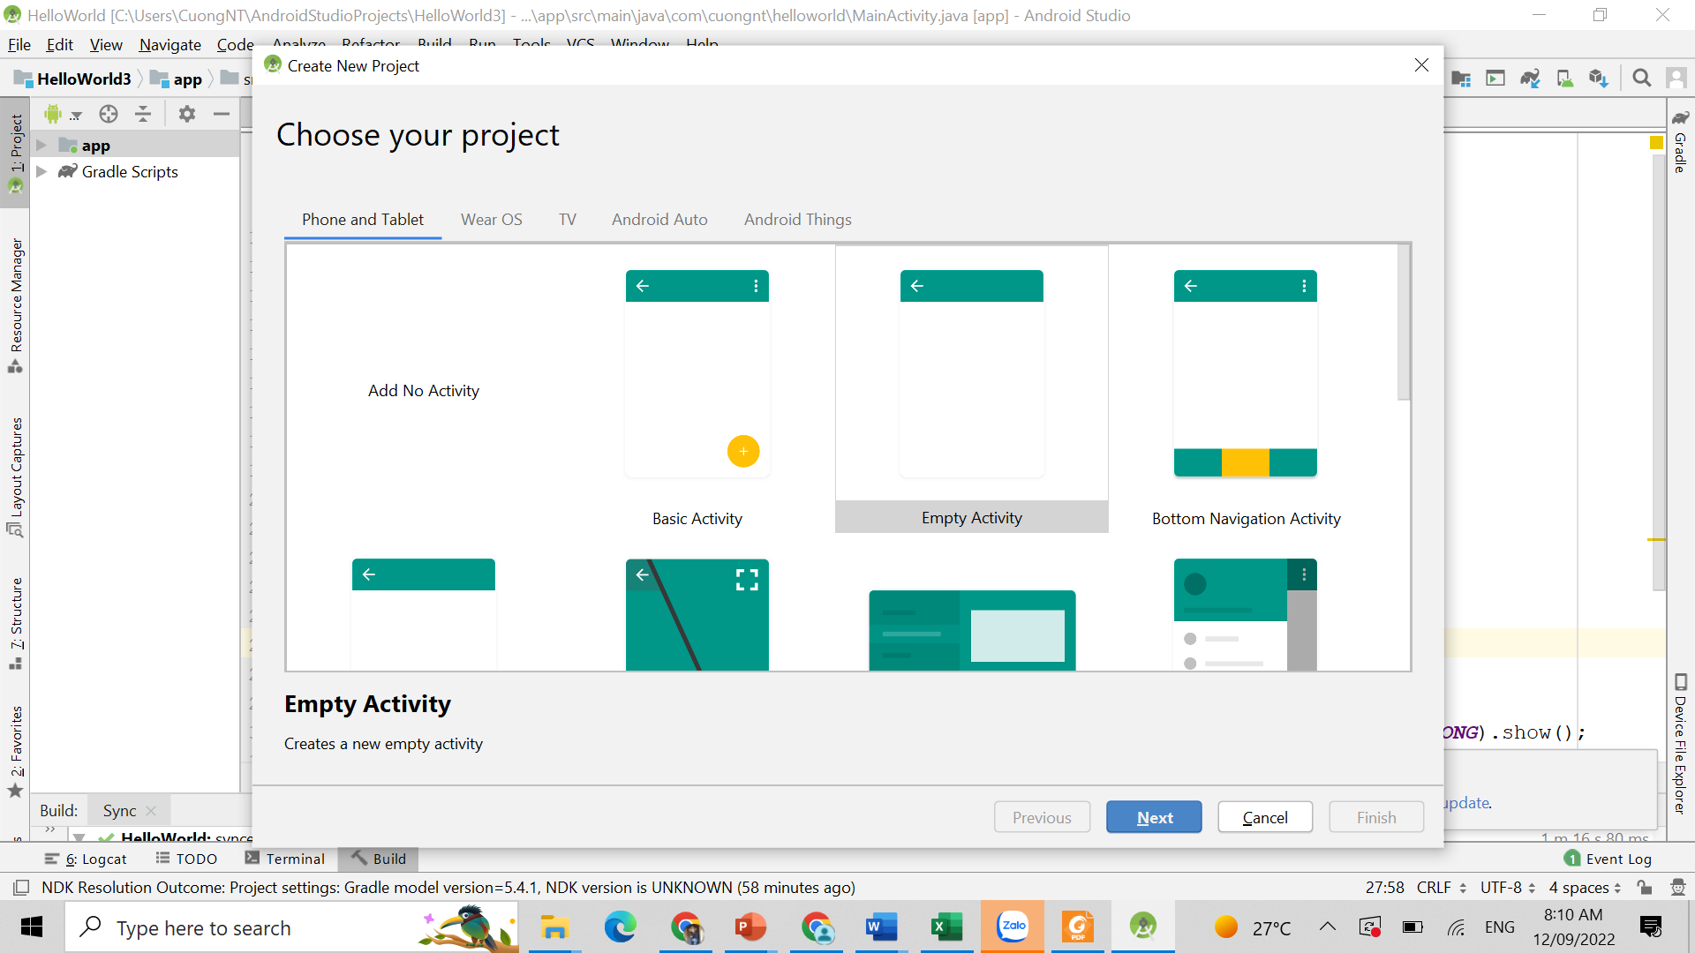

Sau đó chọn các thông tin cấu hình project

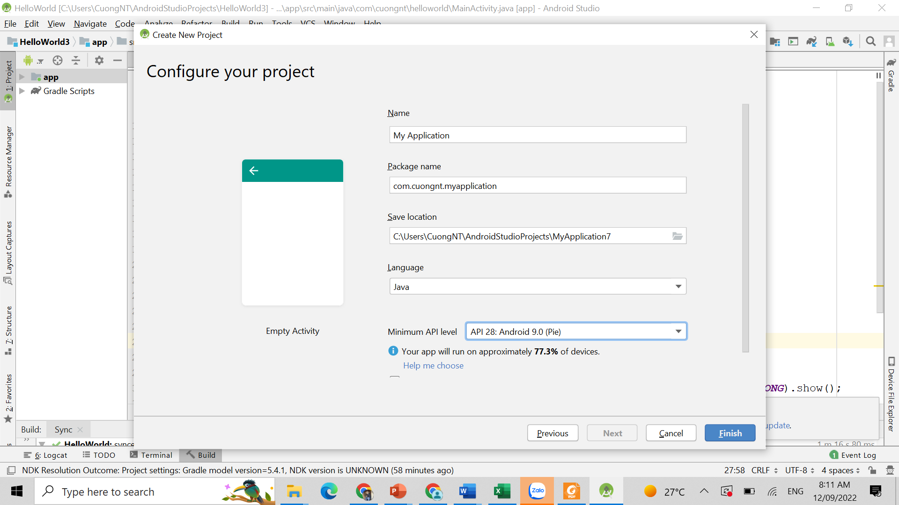

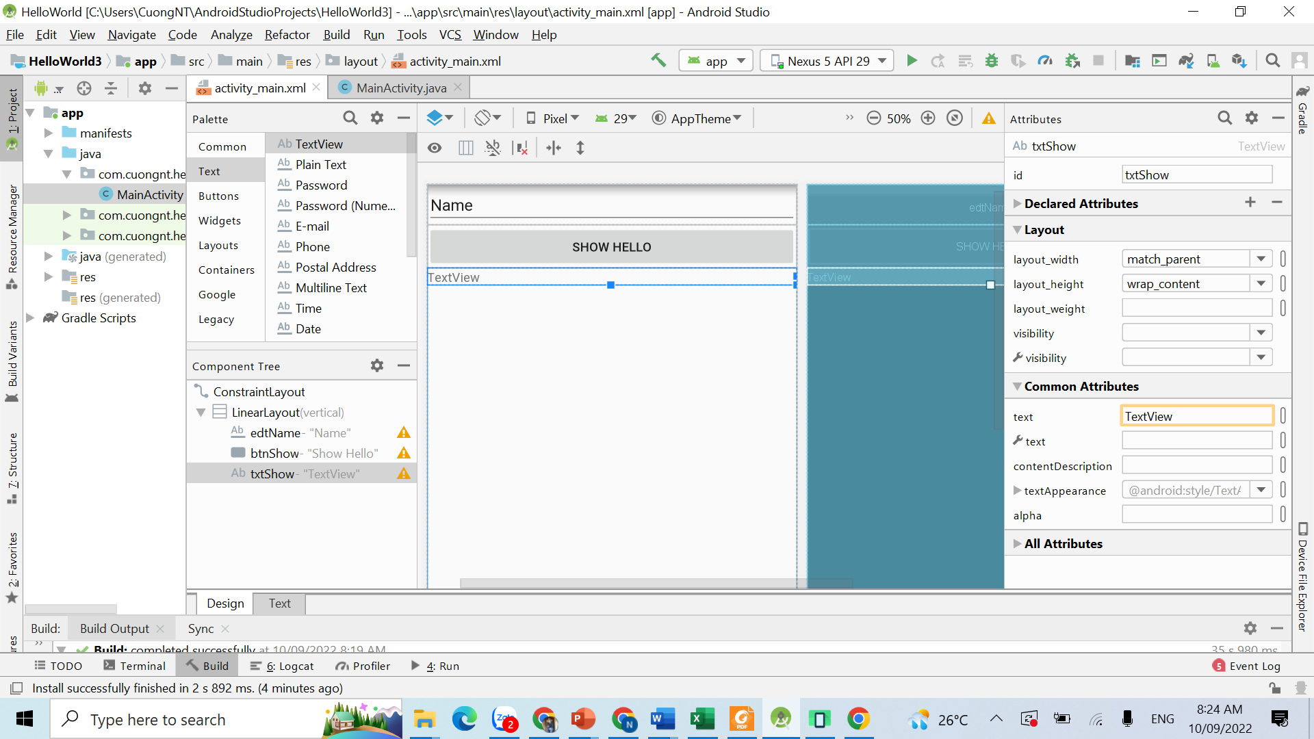

*<?***xml version="1.0" encoding="utf-8"***?>*<**androidx.constraintlayout.widget.ConstraintLayout xmlns:android="http://schemas.android.com/apk/res/android"  
 xmlns:app="http://schemas.android.com/apk/res-auto"  
 xmlns:tools="http://schemas.android.com/tools"  
 android:layout_width="match_parent"  
 android:layout_height="match_parent"  
 tools:context=".MainActivity"**>  
  
 <**LinearLayout  
 android:layout_width="match_parent"  
 android:layout_height="match_parent"  
 android:orientation="vertical"**>  
  
 <**EditText  
 android:id="@+id/edtName"  
 android:layout_width="match_parent"  
 android:layout_height="wrap_content"  
 android:ems="10"  
 android:inputType="textPersonName"  
 android:text="Name"** />  
  
 <**Button  
 android:id="@+id/btnShow"  
 android:layout_width="match_parent"  
 android:layout_height="wrap_content"  
 android:text="Show Hello"** />  
  
 <**TextView  
 android:id="@+id/txtShow"  
 android:layout_width="match_parent"  
 android:layout_height="wrap_content"  
 android:text="TextView"** />  
 </**LinearLayout**>  
</**androidx.constraintlayout.widget.ConstraintLayout**>

**package** com.cuongnt.helloworld;  
  
**import** androidx.appcompat.app.AppCompatActivity;  
  
**import** android.os.Bundle;  
**import** android.view.View;  
**import** android.widget.Button;  
**import** android.widget.EditText;  
**import** android.widget.TextView;  
  
**public class** MainActivity **extends** AppCompatActivity {  
  
 @Override  
 **protected void** onCreate(Bundle savedInstanceState) {  
 **super**.onCreate(savedInstanceState);  
 setContentView(R.layout.***activity_main***);  
 *// khai bao các thanh phần wiget* **final** TextView txtShow=findViewById(R.id.***txtShow***);  
 **final** EditText edtName=findViewById(R.id.***edtName***);  
 Button btnShow=findViewById(R.id.***btnShow***);  
 *// viet su kien onClick* btnShow.setOnClickListener(**new** View.OnClickListener() {  
 @Override  
 **public void** onClick(View v) {  
 *// lay du lieu tu edtName* String name=edtName.getText().toString();  
 *// hien thi vao o txtShow* txtShow.setText(**"Hello "**+name);  
  
 }  
 });  
 }  
}

Toast.*makeText*(MainActivity.**this**,**"Hello "**+name,Toast.***LENGTH_LONG***).show();